University of Engineering and Technology, Lahore
Department of Computer Science

Project Report

Submitted by:
Muhammad Rehan Ilyas (2025-CS-65) Sec-B rehanilyas4726@gmail.com
Muhammad Hassan Rauf (2025-CS-106) Sec-B hassanuniversity98@gmail.com

Submitted to:
Sir Waqas Ali

Course:
CS-101: Discrete Mathematics

DATED:
26-Dec-2025

1.Project Title :
"Propositional Logic Expression Analyzer"

2. Introduction :
The main goal of this project is to create a C++ program that generates truth tables for logical expressions. The program supports both single expressions and double expressions, allowing students and learners to evaluate logical statements, check equivalence, and understand the behavior of Boolean algebra.

3. Motivation :
We chose this project because it makes propositional logic easier to understand in practice. Seeing truth tables and results helps us connect theory with real examples. This project directly relates to what we learned in CS-101 and also improves our problem-solving and programming skills. Manual creation of truth tables is time-consuming and error-prone. By creating an automated truth table generator in C++, we can:
- Quickly evaluate complex expressions.
- Check equivalence of two logical statements.
- Identify tautology, contradiction, or contingency for expressions.

4. Design and Implementation :
4.1 Program Structure :
The program is modular and structured as follows:

- Header and Menu Functions: Display ASCII headers and menus for better user experience.
- Input Functions: Allow the user to input one or two logical expressions.
- Variable Detection: Detect unique variables in expressions, converting lowercase to uppercase.
- Truth Table Generation: Generate all possible combinations of variable values using a binary representation.
- Expression Evaluation: Evaluate logical expressions for each row of the truth table.
- Result Display: Show truth tables in a neatly formatted table using ASCII borders and gotoxy() for positioning.

2.2 Key Features :
- Supports logical operators: !/~ (NOT), & (AND), | (OR), ^ (XOR), > (IMPLICATION), = (EQUIVALENCE).
- Handles parentheses () for grouping expressions.
- Detects equivalence between two expressions.
- Displays whether expressions are tautology, contradiction, or contingency.
- Clean user interface with centered ASCII art and structured menus.

2.3 Implementation Details :
- Used 2D arrays to store truth table values.
- Used functions for modularity: detectvariables, generateTruthTable, evaluateExpression, printTruthTableSingle, printTruthTableDouble.
- gotoxy() function is used to position output on the console for readability.
- Input validation ensures expressions contain only valid characters and properly balanced parentheses.

2.4 Program Flow :
- Display header and main menu.
- User selects single or double expression mode.
- Input expressions are validated.
- Variables are detected and truth table is generated.
- Expressions are evaluated row by row.
- Truth table is displayed and result is analyzed.
- Program loops back to menu until user exits.
- Results and Discussion :
  - Sample output for single expression :

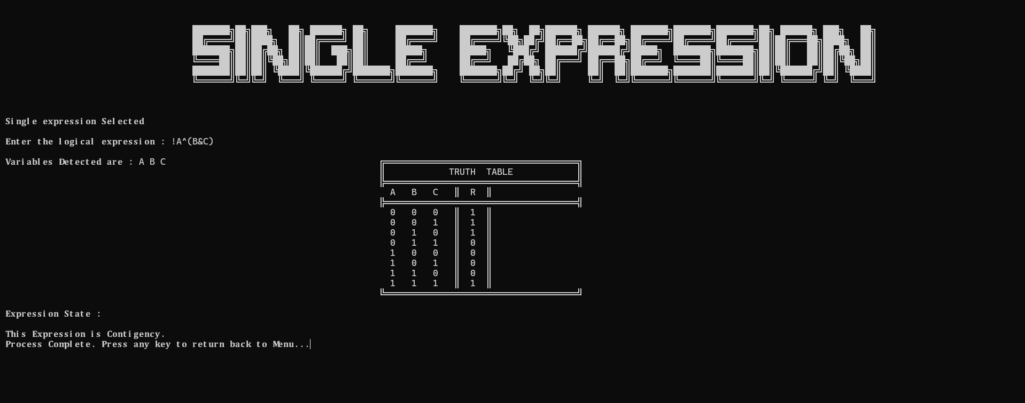

6.1.1 Variable Detection:
- The program correctly detected all unique variables used in the expression (A, B, and C,etc) and displayed them at the top.
- This ensures that all combinations of variables are considered in the truth table.
6.1.2 Truth Table Generation:
- The table lists all 2^n number of possible combinations of truth values for the n variables.
- Each row corresponds to a unique combination of inputs (0 for False, 1 for True).
- The expression is evaluated for each combination, and the results are correctly displayed in the last column labeled R.
6.1.3 Expression Evaluation:
The expression evaluation function correctly applies logical operators:
- ^ (XOR) for exclusive OR.
- & (AND) implied within parentheses.
- ! or ~ (NOT) would have been applied if present.
- The program correctly determines whether the result is 1 (True) or 0 (False) for each row.
6.1.4 Expression State Analysis:
- Based on the results, the program identifies the expression as a Contingency.
- This is accurate because the expression evaluates to True for some combinations and False for others, rather than being always true (tautology) or always false (contradiction).
6.1.5 User Interface and Formatting:
- The truth table is neatly formatted with ASCII borders, clearly separating variables from results.
- The use of centered ASCII headers (e.g., SINGLE EXPRESSION) and proper spacing makes the output easy to read.
- The program also provides clear instructions for returning to the menu after evaluation.

  - Sample output for Double expression :

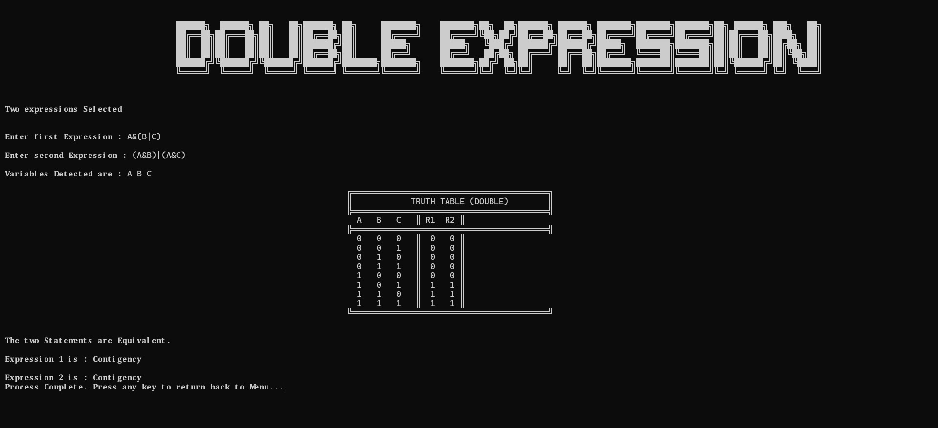

6.2.1 Variable Detection:
- The program correctly detects all unique variables in both expressions (A, B, C).
- Combining variables from both expressions ensures the truth table evaluates all necessary combinations.
6.2.2 Truth Table Generation:
- The table lists all 2^n number of possible combinations of truth values for the n variables.
- Each row contains values for variables A, B, C along with the results of both expressions in columns R1 and R2.
- This allows the user to compare the outcomes of the two expressions side by side.
6.2.3 Expression Evaluation and Equivalence Checking:
- Each row is evaluated using the evaluateExpression function.
- The results show that R1 and R2 produce the same value for all rows (0 or 1), indicating the two expressions are logically equivalent.
- The program correctly identifies equivalence and displays the message: "The two Statements are Equivalent."
6.2.4 Expression State Analysis:
- Both expressions are identified as Contingency, since their results are not always 1 (tautology) or always 0 (contradiction), but a mix of True and False across different input combinations.
- This demonstrates that the program correctly evaluates the logical nature of complex expressions.
6.2.5 User Interface and Formatting:
- The truth table for double expressions is neatly formatted using ASCII borders.
- Results for both expressions (R1 and R2) are aligned for easy comparison.
- Centered headings (DOUBLE EXPRESSION) and spacing make the output readable.
- The program clearly indicates when the evaluation process is complete and instructs the user to return to the menu.

- Conclusion :
This project successfully creates a Logical Truth Table Generator using C++. It bridges the gap between complex mathematical logic and computer programming. By using this tool, users can instantly see how different logical inputs affect the final result of an expression.
  - Key Achievements :
7.1.1 Smart Logic Processing :
The program doesn't just display text; it "thinks" about the math. It uses a custom Evaluation Engine to handle different operators. For example, it knows that an "Implication" (P Q) is the same as saying "NOT P or Q."
7.1.2 Automated Complexity :
Creating a truth table for 3 variables requires 8 rows, but 5 variables require 32 rows. Doing this by hand is exhausting. This program automates the binary math required to fill these rows perfectly every time.
7.1.3 Advanced Comparisons :
One of the best features is the Double Expression mode. It allows students to test "Logical Equivalence." By comparing two different formulas side-by-side, the program can prove if they are mathematically identical, which is a core concept in computer science and philosophy.
7.1.4 Visual Organization :
Instead of a messy list of numbers, the code uses the windows.h library and gotoxy functions. This creates a "Graphical" feel within a text-based window, making the table look like a real spreadsheet.

- References :
- Rosen, K. H. Discrete Mathematics and Its Applications, 8th Edition. McGraw-Hill Education, 2019.
This book was used as the primary reference for understanding propositional logic, logical operators, truth tables, and equivalence of logical expressions. The theoretical foundations of the project, including contingency, tautology, and contradiction, are based on concepts discussed in this text.
- Microsoft Documentation. Windows Console Functions.
Microsoft’s official documentation was consulted for implementing console-based features such as cursor positioning, screen clearing, and output formatting. Functions like SetConsoleCursorPosition were used to control text placement and improve the visual presentation of the console application.
- C++ Reference Documentation. C++ Standard Library.
C++ documentation was referenced to correctly use standard libraries such as <iostream> for input and output operations, <cmath> for mathematical computations. These resources helped ensure proper syntax, functionality, and efficient program execution.
- Github Repository Reference 1: https://github.com/RehanIlyas-dev/Logic-Analyzer.git
- Github Repository Reference 2: https://github.com/Muhammad-Hassan-uet/Logic-Analyzer.git
- Linkedin Reference: https://www.linkedin.com/posts/muhammad-hassan-032415386_im-excited-to-share-our-group-project-based-activity-7414256895907000320- ku92?utm_source=social_share_send&utm_medium=member_desktop_web&rcm=ACoAAF8aAuYBNnkRucYskFdjWFE8fNeA7eRL39k

9 Future Enhancements :

Although the current propositional logic analyzer supports single and double expressions along with operators such as implication and biconditional, several enhancements can still be made in the future. A graphical user interface (GUI) can be developed to make the application more interactive and user-friendly. Additional features such as logical expression simplification, Karnaugh map generation, and step-by-step evaluation of expressions can be added. Improved error handling and input validation would help users understand and correct mistakes easily. Moreover, options to export truth tables and results to files for documentation purposes can also be included.

